Initial Project Proposal

Year: _2021_ Semester: Spring Project Name: Smart Conveyor Belt System

Creation Date: _____December 16, 2020_ Last Modified: January 21, 2021

Team Members (#1 is Team Leader):

Member 1: _Jason Cao__________________ Email: _____cao216@purdue.edu_____

Member 2: _Zicong Wang_______________ Email: _____wang4166@purdue.edu__

Member 3: _Ryan Eastman______________ Email: ____reastman@purdue.edu___

Member 4: _Jonah Shader__________ Email: ____jshader@purdue.edu____

1.0 Description of Problem:

The efficiency of delivering products is a monumental task that still poses problems to the e-commerce companies of today. Methods such as the use of conveyor belt systems have become more and more complex and as such, would increase maintenance costs should individual parts fail.

Pre-existing conveyor sorting systems push parcels off from one “mainline” belt to another belt. A noticeable problem with this system is that parcels have to slow down when they are being pushed off from the “mainline” belt, which could cause parcel congestion on the “mainline” belt. In the case of warehouse operators, parcel congestion would equate to slower and less accurate deliveries.

2.0 Proposed Solution:

Our proposed solution is a conveyor belt system that is capable of sorting objects based on object detection analysis, while involving fewer moving parts than pre-existing solutions.

To start, the objects would first be placed onto a primary conveyor belt that has a length of 30 cm, (which is enough for the scanning process) while running at a speed of 24 to 28 cm/s. As the objects are moving, the barcode scanners positioned above, below, to the left of, and to the right of the object would scan the barcode tag (1D, ITF) that is on the object. The information retrieved from these sensors would interface with the microcontroller through the USART pins. The barcode scanner will be an omnidirectional laser*(possibly led scanner speed vs cost is the issue here). Without stopping, the object moves onto a secondary belt of length 60 cm while going at a faster speed of 30 cm/s. They conveyor belts would utilize DC brushed motors for general movement, with sorting flaps using DC servo motors for movement and direction control. The maximum amount of time a package would need to traverse the sorting system would be 4 seconds. Later, the objects come to the sorting area where sorting flaps will guide the objects into their respective sorting compartments based on the barcode information.

These flaps have 2 positions. The first position is 45 degree angle from the wall to allow objects to slide off the belt into the sorting compartment. The second position would have the flap be flush with the wall to allow objects to move past a specific sorting compartment.

Our solution is highly scalable and cost-effective compared to other industrial implementations which are limited by fixed product scales or highly complex and expensive components. (Images of sketches included in the appendix).

3.0 ECE477 Course Requirements Satisfaction

3.1 Expected Microcontroller Responsibilities

The expected responsibilities of the microcontroller would be to read the value that is produced by the barcode scanner. The scanner will need to be omnidirectional and laser* in order to read the label quick enough. The microcontroller would receive the value from the barcode scanner through its USART pins and sort objects into different sorting containers using motors controlled by the driver board.

3.2 Expected Printed Circuit Responsibilities

For our project, the custom printed circuit board would be a motor driver board, which is connected to two DC brushed motors that drive the belt and three servos that control the sorting flaps. It would be responsible for receiving signals from the microcontroller that specify whether the belt motors should be on or off and the position the servos should be in.

To drive the belt, we would have a simple circuit that applies a voltage to the brushed DC motors when an in-line transistor or relay receives a 1 or 0 from the microcontroller. The voltage needed to drive these motors is higher than the microcontroller operating voltage, so they will be powered by a separate power supply.

For the flaps, each servo will only require a supply voltage and a pwm signal. For each servo, the pwm signal would come from the microcontroller to a simple, single-transistor amplifier, and then to the servo input. The supply voltages can come directly from a separate power supply.

4.0 Market Analysis:

Our potential customers would be various scales of retailer companies, such as Amazon, Walmart, CVS, etc. These retailers usually own local and central warehouses and storages big enough where they can benefit from a smarter redistribution system. Our customers could use it to store packages into different storages based on factors like delivery destination, or simply distribute them to different tracks, customizable by our customer’s desire.

Over 90% of the cost of our product would consist of the two conveyor belts, averaging around $500 in total. With additions of microcontroller and miscellaneous costs, the total cost would be around $700, and we could set our price to be near $1100. While this may seem pricey, it is actually cost efficient for retailing companies because it replaces the job needed by multiple staff members, therefore reducing companies’ costs on salary, or possibly a plethora of regular conveyor belts and motors, which by estimate could easily cost over thousands of dollars.

By the characteristics of our conveyor belt system design, our product won’t be purchased in great quantity for one warehouse. However, if we could secure a deal with one or two big retail companies, we could theoretically yield great profits. For example, Amazon has over 180 warehouses, and Walmart has over 150, Suppose each warehouse only orders ten of these(this number would be much more in a real scenario for they have many destinations nationwide and globally), it would yield over $130,000 in revenue.

5.0 Competitive Analysis:

5.1 Preliminary Patent Analysis:

5.1.1 Patent #1:

US Patent Application US6878896B2

**Patent Title**: Synchronous semi-automatic parallel sorting

**Patent Holder**: United Parcel Service of America Inc

**Patent Filing Date:** 2002-07-24

The patent assigned here relates to organizing parcels by cubbys from multiple layers of conveyor belts. The system pushes parcels off the belts into cubbys as they are passing by. The advantage of this is more parcels can be sorted at the same time. The disadvantages are a high number of pistons to maintain and timings that cannot be missed. The proposed solution relies on less moving parts per organizational space in addition to using less power by using gravity to move packages.

5.1.2 Patent #2:

**US Patent Application:** US6554123B2

**Patent Title**: High Speed parcel sorter

**Patent Holder**: United Parcel Service of America Inc

**Patent Filing Date:** 2002-05-16

This patent uses conveyor belts and places them on pivots so they can tilt packages to the left or right into parcel containers or separate tracks. This allows for rapid package sorting as packages are moving around conveyor belts. The advantages are the speed at which the parcels can be sorted and the compactness of the units for doing so. The proposed solution advantages over this solution are ease of maintenance and if a unit goes down in the proposed solution the wall can simply be set to parallel with the track and fixed there whereas the patent can suffer from alignment issues with the pivot causing packages to slide off and the belt itself failing and stopping.

5.1.3 Patent #3:

US Patent Application US4058217A

Patent Title: Automatic Article Sorting System

Patent Holder: Unisearch Ltd.

Patent Filing Date: 1977-11-15

The expired patent here relates to the use of labels that contain information and instructions for packages that are being processed. Our proposed solution uses this directly as we’ll be using either RFID tags or barcodes to tag packages with instructions for sorting. This patent is expired so there’s no legal issues in using this method in our system.

5.2 Commercial Product Analysis:

5.2.1 EZ - Flats Pro by Engineering Innovation - Commercial Product #1:

**Functionality**:

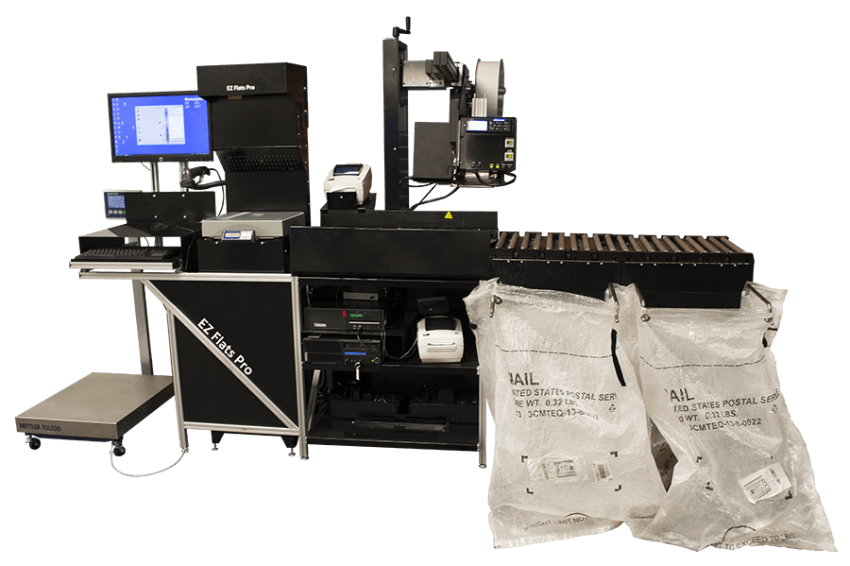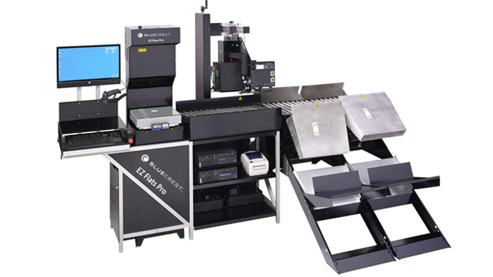

The first commercial product is from Engineering Innovation, a mail and parcel sorting equipment company in Lafayette. Their product EZ-flats Pro pushes objects off the conveyor belt into tracks, depending on their sizes. However, they are using the ends of roller bars on the conveyor to achieve this, making it more reliable and safer. This system has low overhead and start-up cost, and is scalable.

**Advantages vs. Our Solution**:

A more precise scan as this solution includes several layers for reducing error such as a human creating the barcodes, and the scan of the barcodes for each item. Therefore, boxes are always placed in correct bins instead of having objects detected by size or weight.

**Disadvantages vs. Our Solution**:

The one major disadvantage of this system is that it still requires one person prior to sorting to constantly monitor the computer, and scanning barcodes before manually putting packages onto the conveyor belt sorting system. This disadvantage affects the clients in a subtle way, as customers consider this system an upgrade to reduce cost, but rarely realize labor cost could be further reduced.

Another disadvantage of this system is that it does not account for parcels or boxes with fragile items, as it generates a push and fall of the boxes where items could potentially break.

5.2.2 Celluvayor by Cellumation - Commercial Product #2:

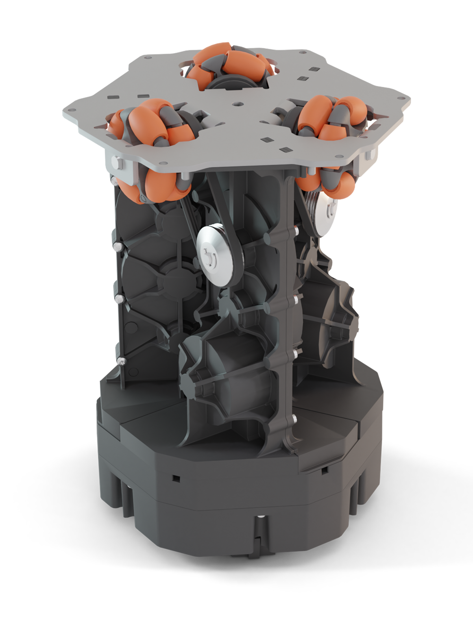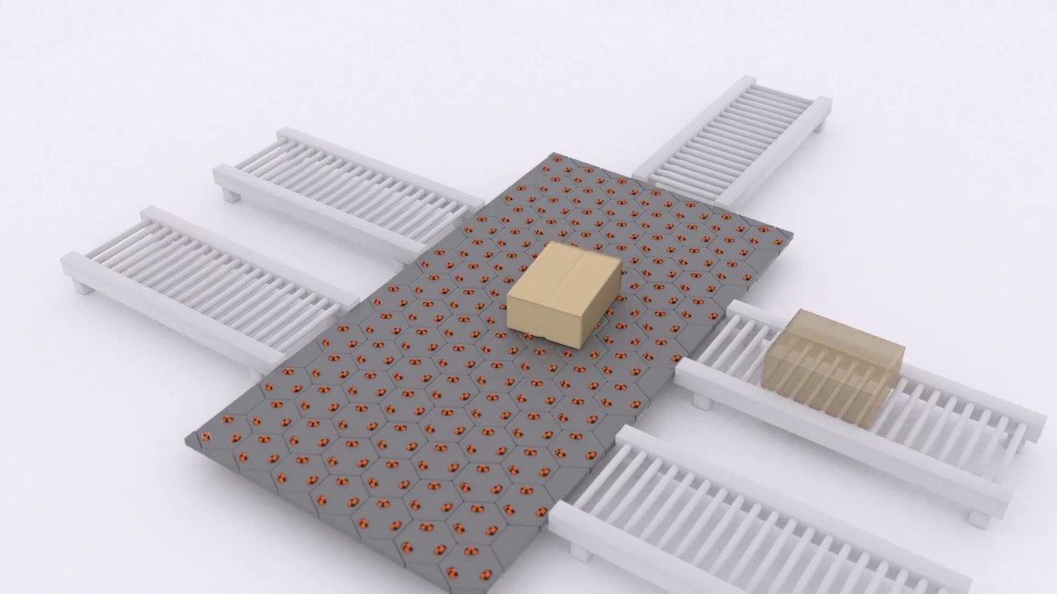

**Functionality**:

The celluvayor is a hexagonal unit that contains omnidirectional wheels that can be brought together to form a smart belt and sorting system in any shape or size, according to preference. This system enables boxes to be moved freely at any direction and orientation, thus enabling a simple way to organize and move objects from different belts or systems to boxes or other systems at hand. Within each cell of the conveyor system, the Celluvayor detects the object’s position at all times and can provide different functionalities according to incoming software specifications for the objects (size, weight). The Celluvayor does not provide any object detection beforehand and only makes its sorting decisions according to hardware specifications done by software, or by using another system that can be integrated with the Celluvayor.

**Advantages vs. Our Solution**:

The advantages against our solution is that the Celluvayor provides an omnidirectional movement for all boxes, and giving them room for a more precise and detailed sorting when transporting different boxes. This system also accounts for multiple boxes at the same time, having no issue with moving boxes to incorrect bins or belts.

**Disadvantages vs. Our Solution**:

One of the disadvantages against our solution is that it’s more complex and more prone to failure. Since all cells within this system are acting simultaneously when sorting an object through a specific path, it requires more motor drivers than our solution would for sorting one box.

5.2.3 Hytrol ProSort 100 by Cisco Eagle - Commercial Product #3:

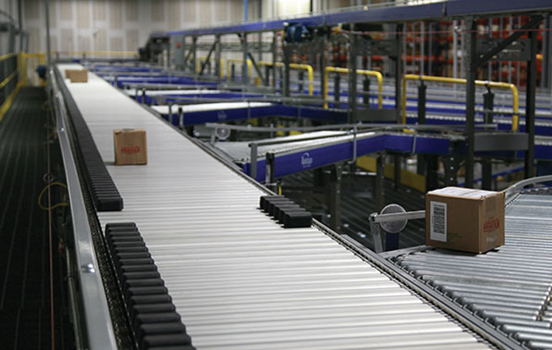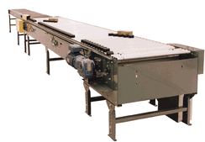

**Figure 1 Figure 2**

**Functionality**:

The Hytrol ProSort is a sorting conveyor system where parcels carried in the flight tubes are moved to either left or right of the belt with the gentle touch of the shoe conveyors on both sides of the belt. When moving parcels to either side, the shoe conveyor stays in the side the parcel has been placed in, and moves again to the other side when sorting another box or parcel that has to be moved to the other side. When parcels have to be moved to either side, the shoe conveyor leaves an opening between each so that boxes could go through and fall in their respective bins or belts.

**Advantages vs. Our Solution**::

The advantages against our solution is that this system can provide a more gentle push for the boxes than flaps, therefore accounting for boxes that may contain fragile items or boxes where items shouldn’t be moved around as hard.

**Disadvantages vs. Our Solution**:

The disadvantage against our solution is that this system has a high probability of error when sorting different parcels at the same time. If 2 parcels are in the belt, and the first parcel gets sorted to the right, and the next one has to be sorted to the left (assuming both boxes are right next to each other, or one right after the other), there may be some collision between shoe belts. Therefore, this system has to be a one parcel sorting system at a time.

5.3 Open Source Project Analysis:

5.3.1 Design and Development of a PLC Based Automatic Object Sorting:

This research paper proposed using a conveyor belt system to sort object traits like colour, and weight through image processing [1]. The paper utilizes a programmable logic controller (PLC) to control two DVD drives that push the object on the belt into two separate containers. One noticeable drawback was that there was a 5-second delay for the DVD drives to fully close after pushing an object off the conveyor belt. The design generated by our group would create a ramp to the sorting bins to reduce the amount of time the conveyor is stopped for after each sorting operation. One portion of this proposal that could be adapted for our project use is the object placing mechanism. In the original proposal, a DVD drive controlled by the PLC was used to push objects onto the conveyor belt. One possible area is for spacing out the objects on our conveyor belt before the sorting process begins.

According to the International Journal of Research and Scientific Innovation, there is no copyright assigned to the paper submission in accordance to the following author declaration form (<https://www.rsisinternational.org/images/Author%20(s)%20Declaration.pdf>). There was no information found about license usage.

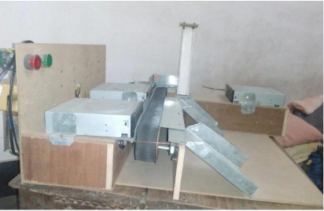

5.3.2 Color Sorting System: Arduino Based System With Two Belts:

This open source project uses an Arduino that connects to a motor driver board for two conveyor belt motors, reads information from the ultrasonic sensor, which measures the distance from the beginning of the main conveyor belt as it moves the object towards the color sensor [2]. The belt then stops when the object is in front of the color sensor. After the color sensor feeds information back to the Arduino, the object is dropped onto the secondary conveyor belt and moves left or right depending on the object colour to be sorted. This project is simple to assemble, which means that there are not many moving parts to fix should any fail. However, this conveyor belt only has capacity for one object, whereas our project would need to accommodate multiple objects that need to be sorted without stopping the belt. One portion that may be adaptable is the usage of simple materials for the conveyor belt. This conveyor belt does not require proprietary materials and may be beneficial when attempting to quickly source parts.

This project was found on a website called “Instructables.com”. This site is associated with or managed by AutoDesk Inc. According to the Terms of Use section 8, “Proprietary Rights”, “*you may (a) view any content on the Site to which we provide you access hereunder on any single computer solely for personal, informational, non-commercial purposes, and (b) download and print one (1) copy of materials that Autodesk specifically makes available for downloading (such as white papers) (the "Documents") from this Site solely for personal, informational, non-commercial purposes, provided that the Documents may not be modified or altered in any way. You may not use, download, upload, copy, print, display, perform, reproduce, publish, license, post, transmit, rent, lease, modify, loan, sell, distribute, or create derivative works based (whether in whole or in part) on, the Site or any information from this Site, in whole or in part, without the express prior written authorization of Autodesk*”.

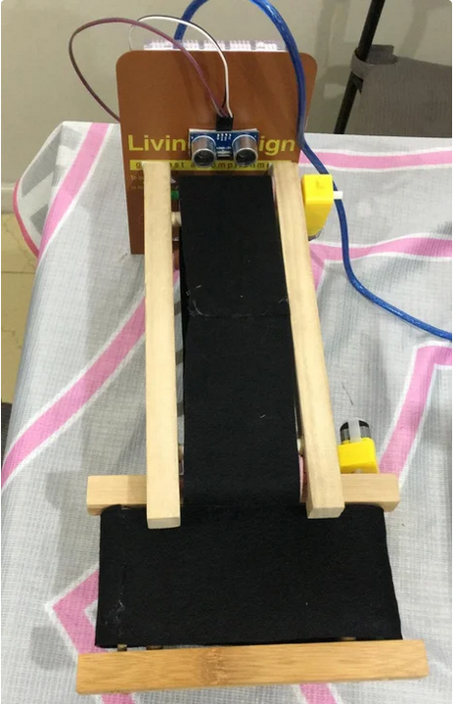

5.3.3 Model Design and Simulation of Automatic Sorting Machine Using Proximity Sensor:

This research paper proposes the sorting objects using a detecting sensor to determine whether the object is a metal or non-metal, and moving them with the conveyor belt in front of double acting cylinders, which push them into sorting compartments [3]. This system has numerous advantages such as being capable of determining objects’ materials in a few seconds. The paper states the system took 9.9, 14.1, and 18.5 seconds to determine sort plastic, wood, and steel objects respectively. However, one drawback with this system is that if the system needed to be scaled from 3 to 6 sorting compartments, the conveyor belt needs to be extended to include more double acting cylinders. One part of this proposal that could be adapted to our project is the use of double acting cylinders. It is possible that an equivalent could be used to rapidly sort objects that continuously move on a conveyor belt.

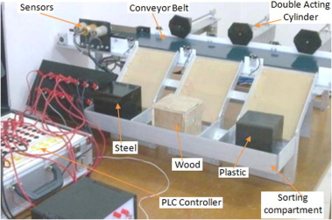

6.0 Sources Cited:

[1] K. Sasidhar, S. F. Hussain, S. A. Safdar, M. A. Uddin, “Design and Development of a PLC Based Automatic Object Sorting,” *International Journal of Research and Scientific Innovation (IJRSI),* vol. 4, no. 12, pp. 10-13, 2017

[2] e_Darwish, “Color Sorting System: Arduino Based System With Two Belts,” instructables.com, n.d. [Online]. Available: <https://www.instructables.com/Color-Sorting-System-Arduino-Based-System-With-Two/>. [Accessed Dec. 22, 2020]

[3] B. I. Oladapo, V. A. Balogun, A. O. M. Adeoye, C. O. Ijagbemi, A. S. Oluwole, I. A. Daniyan, A. E. Aghor, A. P. Simeon, “Model Design and Simulation of Automatic Sorting Machine Using Proximity Sensor,” *Engineering Science and Technology, an International Journal,* vol. 19, no. 3, pp. 1452-1456, 2016

[4] cellumation. 2020. *Celluveyor - Cellumation*. [Online] Available at:

https://cellumation.com/celluveyor/ [Accessed 23 December 2020].

Appendix 1: Concept Sketch

**Figure 1 Figure 2**

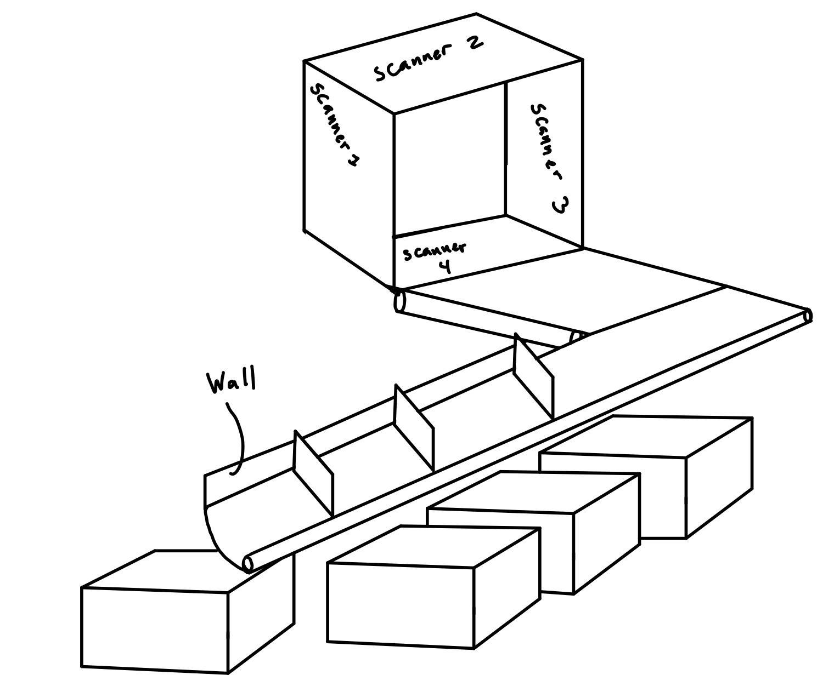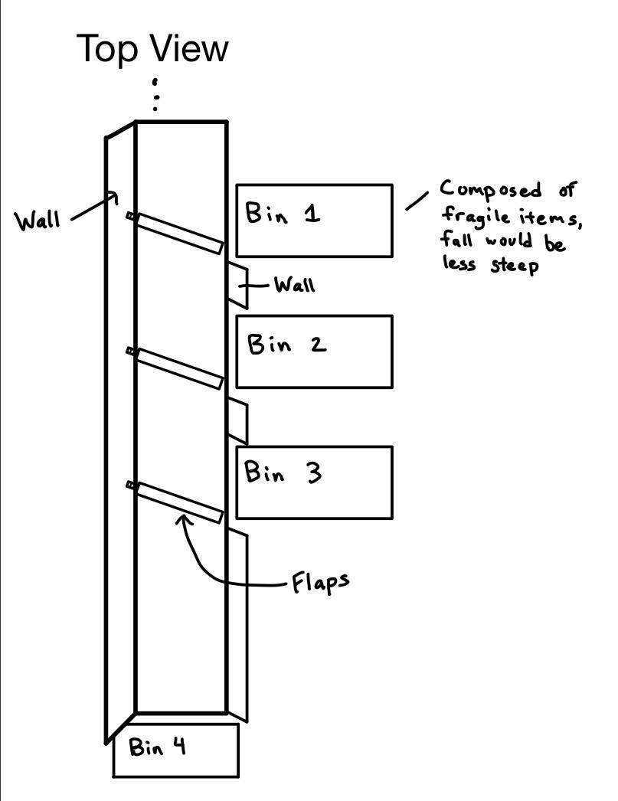

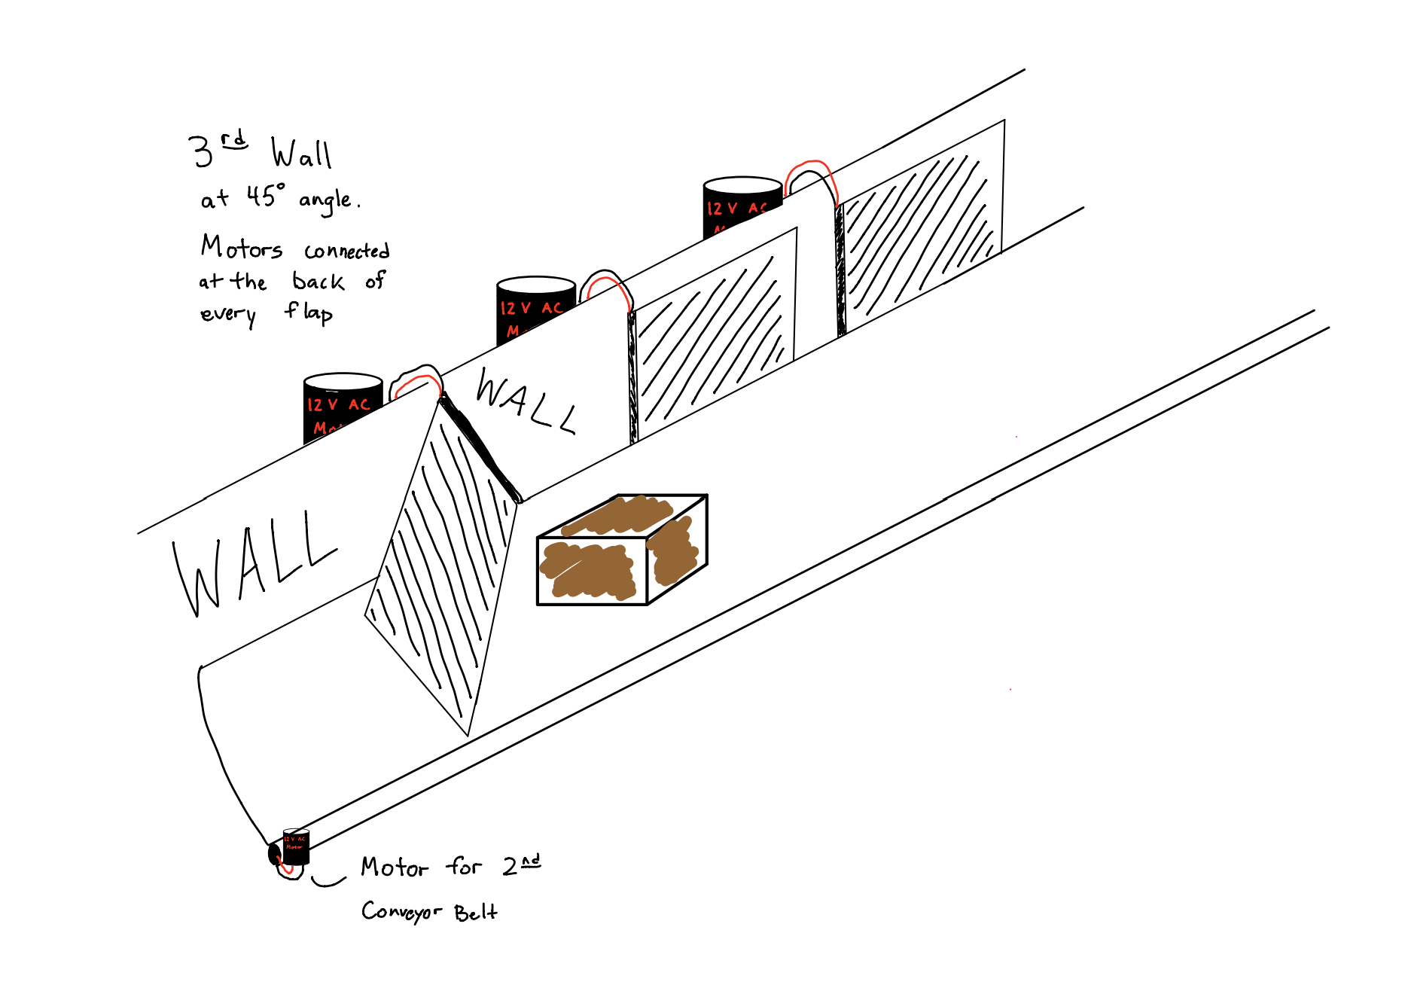

**Figure 3 (above).** Hinges connected to every wall would be motorized, turning every flap at either a 45 degree angle, or at an angle pushed against the wall, that would allow boxes to pass through the designated flap.

**Functional Sketch**

